LABORATORY EXERCISE 4

CPU SCHEDULING (FCFS, SJF, PRIORITY)

Learning Objectives
- Understand the concepts and mechanics of fundamental CPU scheduling algorithms.
- Analyze the differences between preemptive and non-preemptive scheduling.
- Evaluate the performance of different algorithms using key metrics like Average Waiting Time and Turnaround Time.
- Develop a simulation program to visualize the scheduling process and its outcomes.

Prerequisite student experiences and knowledge
Students should have a basic understanding of processes, CPU bursts, and arrival times. Prior programming experience in Java or C++ is required.

Background
CPU scheduling is a fundamental function of any operating system. When multiple processes are ready to run, the OS must decide which one to assign to the CPU. Different scheduling algorithms make this decision based on different criteria (e.g., arrival time, burst time, priority), leading to varied system performance and behavior. Understanding these algorithms is crucial for analyzing system efficiency and fairness.

Materials/Resources
- A computer with a Java JDK or a C++ compiler installed.
- Integrated Development Environment (IntelliJ IDEA, Eclipse, NetBeans, or Visual Studio Code).
- Documentation tools (e.g., Microsoft Word, screenshots).

Laboratory Activity
Instructions: Implement a menu-driven program in Java or C++ that simulates the following CPU scheduling algorithms:
- First Come First Serve (FCFS)
- Shortest Job First (SJF) – Non-Preemptive
- Shortest Job First (SJF) – Preemptive
- Priority Scheduling – Non-Preemptive
- Priority Scheduling – Preemptive

Program Requirements
- The program must present a menu for the user to select which algorithm to simulate.
- For the selected algorithm, the program should accept user input for a set of processes, including:
  - Process ID
  - Arrival Time
  - Burst Time
  - Priority (for Priority Scheduling algorithms)
- The program must then:
  - Display an input/output table showing the original process details and the calculated results (Waiting Time, Turnaround Time for each process).
  - Generate and display a Gantt Chart representing the simulation.
  - Compute and display the following performance metrics:
    - CPU Utilization
    - Average Waiting Time (AWT)
    - Average Turnaround Time (ATT)

Note:
- Your code should be well-commented and organized.
- Include screenshots of your program's output for at least three different algorithms to support your observations.

Sample Input/Output
- Input
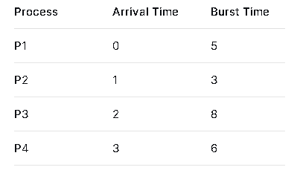
- Gantt Chart
- Output
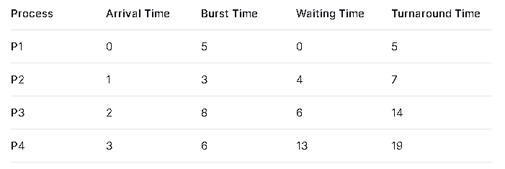
- Performance Metrics
  - CPU Utilization: 100%
  - Average Waiting Time (AWT): (0+4+6+13)/4 = 5.75
  - Average Turnaround Time (ATT): (5+7+14+19)/4 = 11.25

QUESTIONS (10 pts each)
- Based on your simulation results, which algorithm provided the best (lowest) Average Waiting Time for the same set of processes? Explain why this is the case theoretically.
- What is the fundamental trade-off between preemptive and non-preemptive scheduling? Provide an example from your simulation where the preemptive version of SJF or Priority scheduling leads to a different outcome than the non-preemptive one.
- How does the First-Come-First-Serve (FCFS) algorithm handle processes with long burst times, and what is the potential negative effect on other processes?

Output / Results

Conclusion

